**UST Pulse – Information Day Demo**

Huamin Qu, CSE, HKUST

**Project Summary**

The objective is to promote campus data access and facility management and showcase our technology for smart campus. Our major work is to sense crowds on campus based on Wi-Fi access point usage information and CCTV videos, visualize such crowd flows in an appealing and engaging form, and feed information to the on-screen display at the SENG Commons. The approach is first to infer the crowd level, which includes to identify crowding spots and rush hours on campus by processing Wi-Fi access point data and CCTV videos. The pre-processed data are characterized by spatio-temporal big data. Uncovering patterns behind such data is also an important research topic. Besides, the rapidly developing technologies such as deep learning and data analytics enable us to estimate real-time waiting time for canteens, buses, toilets, etc. and predict congestion time and areas. With such processed information, we can integrate visualization into data analytics, which displays the dynamism of a walking-traffic network on campus in different buildings and time periods in an aesthetically pleasing way. The exhibition on three screens at SENG Commons allows visitors and students to share the benefits of smart campus. This kind of work can be useful for special events like Info Day and also beneficial to future studies in campus behavior or even city-level behavior, transport management, and facility scheduling.

To this end, our team has the expertise on the project and is already a leader in big data and narrative visualization. Specifically, we have devoted our efforts to urban big data visualization [1, 2], whose vision is to build smart cities using spatio-temporal data such as automobile trajectories and map data. Crowd flow analysis on campus is similar to urban data analysis. We can leverage our knowledge in urban practice to create impressive campus visualizations. Our group is also experienced on narrative visualization with engaging designs. For example, our recent work, InfoNice, which presents a visualization design tool to create expressive data-driven infographics, has been published on CHI 2018[3]. Besides, we also conducted a survey on storytelling and visualization work [4] and made attempts such as animated narrative visualization for video clickstream data [5]. They are all well received.

In addition, we have worked on the project, ‘Pulse of HKUST’, for three years. Our coauthorship graph has been online in the library website since 2016. Notably this year, we actively connect with ITSC to get the campus wifi data so that we can integrate crowd visualization into our project, which greatly enriches the contents. Up to date, we have delivered two prototypes to visualize events and crowds in the campus.

**Deliverables for Info Day**

From latest discussion, we received confirmation from the department to use three projector screens at Engineering Commons for HKUST Info Day. In this project, we intend to display the blossoming of the School of Engineering by demonstrating comprehensive strengths, visualizing real-time crowd flows, and presenting various events organized by SENG. The major contents for each screen are shown in the Figure and described as follows.

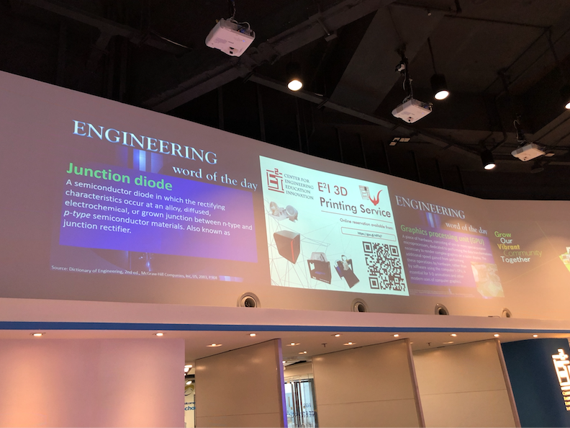

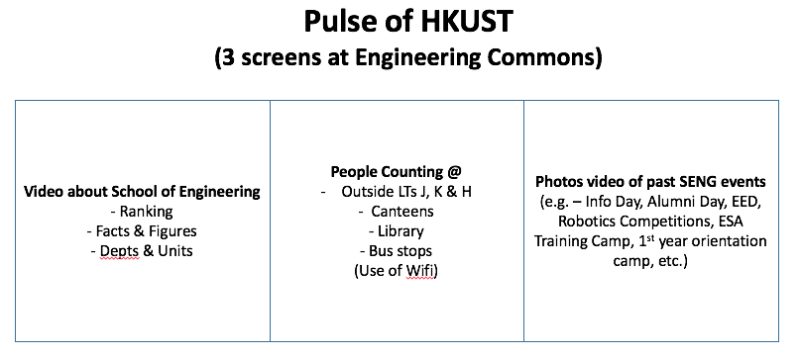

**Left: Visualizing Development of SENG**

In this screen, we are going to show the comprehensive strengths of SENG from three perspectives, i.e., rankings, facts and figures, departments and units.

* Rankings

The School of Engineering of HKUST is rated high in prestigious engineering rankings worldwide. Visualizing the rising trend of our university and school rankings shows the leading academic force.

* Facts and figures

SENG are internationally recognized around the world. Excellent students from all over the world are attracted by education and research achievements each year. Faculty members enjoy high reputation and build connections worldwide. Graduate students also have good opportunities for their further development. Presenting all this information such as student numbers, faculty members, graduate employment, and research funding, in a well-organized way could give an overview of the School of Engineering.

* Departments and Units

The school is proud of its comprehensive range of engineering disciplines, including six departments and one division, namely, CBE, CIVL, CSE, ECE, OEDA, MAE, and ISD. We are going to give a brief introduction of all these departments and units for visitors and students.

**Middle: Visualizing Crowds in the Real Time**

On Info day, it is likely that the campus is full of visitors and students. Providing a satisfactory experience with limited public services can be a challenge. A feasible method is to apply campus big data analysis to provide solutions for crowd issues. For example, we can visualize crowd movements and predict waiting time for busy areas based on Wifi data. It allows visitors and students to arrange and adjust their schedule. A special design with animation effects is preferred to increase user experience. This screen is going to show the crowd evolvement combined with video shots. Counts of people will be updated almost in real time (with 5-minute interval) and it can be differentiate visitors from students. In practice, we are going to design different representations for different areas.

* Canteens and Library

Since there could be a large number of people on Info Day, the canteens and library could be crowded. Visualizing the waiting time for these zones is of great help.

* Bus Station

ITSC will install total 3 HD cameras at both north and south stations. Combined with video processing results and wifi data, we could have a better estimate for the waiting time of the bus and taxi.

* Outside LTs J, K & H

The School holds a series of lectures in LTs J, K and H on Info day. People might wait outside these rooms before the lecture. Presenting information about the waiting queues could give advisements for students and visitors to choose lectures.

* Facility usage

ITSC considers installing sensors, for example, sensors at the door or CO2 sensors to calculate number of people in the toilets. However, it would be ready around early September. We are considering whether this would be appropriate to be combined into our project. And if we want to integrate this, we need to provide them with prioritized list of toilet locations.

**Right: Visualizing SENG Various Events**

SENG has organized various events for their students every year, for example, HackUST, Robotics Competitions, ESA Training Camp, Engineering Exploration Day. Presenting these events in a fascinating way gives students a deeper understanding of life in School of Engineering. In this screen, we are going to show an event calendar, which displays SENG colorful activities over the past two years. All the event recordings including photos and simple introduction are provided by the department.

**Budget**

3 RA x 4 months X HK$16k per month = HK $192

[1] D. Liu et al., "SmartAdP: Visual Analytics of Large-scale Taxi Trajectories for Selecting Billboard Locations," in *IEEE Transactions on Visualization and Computer Graphics*, vol. 23, no. 1, pp. 1-10, Jan. 2017.

[2] W. Wu et al., "TelCoVis: Visual Exploration of Co-occurrence in Urban Human Mobility Based on Telco Data," in *IEEE Transactions on Visualization and Computer Graphics*, vol. 22, no. 1, pp. 935-944, 31 Jan. 2016.

[3] Y. Wang, et al. "InfoNice: Easy Creation of Information Graphics." *Proceedings of the 2018 CHI Conference on Human Factors in Computing Systems*. ACM, 2018.

[4] C. Tong et al., "Storytelling and Visualization: An Extended Survey", in *Information*, vol.9, no. 3, 2018.

[5] Y. Wang, et al. "Animated narrative visualization for video clickstream data." *SIGGRAPH Asia 2016 Symposium on Visualization*. ACM, 2016.